**session12 Assign1**

Ashish Saxena

1. Perform ANOVA test on the discriminant analysis scores of nuclear localization signals of both nuclear and non-nuclear proteins by class variables (Target).
2. Which class is significantly different from others?

|  |
| --- |
| *#1. Title: Protein Localization Sites*      *#2. Creator and Maintainer:*  *# Kenta Nakai*  ##Osaka, University  ##nakai@imcb.osaka-u.ac.jp  *# http://www.imcb.osaka-u.ac.jp/nakai/psort.html*  *#Donor: Paul Horton (paulh@cs.berkeley.edu)*  *#Date: September, 1996*  *#See also: ecoli database*    *#3. Past Usage.*  *#Reference: "A Probablistic Classification System for Predicting the Cellular # Localization Sites of Proteins", Paul Horton & Kenta Nakai,* *# Intelligent Systems in Molecular Biology, 109-115.*  *# St. Louis, USA 1996.*  *#Results: 55% for Yeast data with an ad hoc structured*  *# probability model. Also similar accuracy for Binary Decision Tree and* *# Bayesian Classifier methods applied by the same authors in* *# unpublished results.*    *#Predicted Attribute: Localization site of protein. ( non-numeric ).*      *#4. The references below describe a predecessor to this dataset and its*  *#development. They also give results (not cross-validated) for classification #by a rule-based expert system with that version of the dataset.*    *#Reference: "Expert Sytem for Predicting Protein Localization Sites in*  *# Gram-Negative Bacteria", Kenta Nakai & Minoru Kanehisa,*  *# PROTEINS: Structure, Function, and Genetics 11:95-110, 1991.* |

|  |  |  |
| --- | --- | --- |
| *#Reference: "A Knowledge Base for Predicting Protein Localization Sites in* | |  |
| *# Eukaryotic Cells", Kenta Nakai & Minoru Kanehisa,*  *# Genomics 14:897-911, 1992.*      *#5. Number of Instances: 1484 for the Yeast dataset.*    *#6. Number of Attributes.*  *# for Yeast dataset: 9 ( 8 predictive, 1 name )*    *#7. Attribute Information.*  *# 1. Sequence Name: Accession number for the SWISS-PROT database*  *# 2. mcg: McGeoch's method for signal sequence recognition.*  *# 3. gvh: von Heijne's method for signal sequence recognition.*  *# 4. alm: Score of the ALOM membrane spanning region prediction program.*  *# 5. mit: Score of discriminant analysis of the amino acid content of* *# the N-terminal region (20 residues long) of mitochondrial and*  *# non-mitochondrial proteins.*  *# 6. erl: Presence of "HDEL" substring (thought to act as a signal for* *# retention in the endoplasmic reticulum lumen). Binary attribute.*  *# 7. pox: Peroxisomal targeting signal in the C-terminus.*  *# 8. vac: Score of discriminant analysis of the amino acid content of* *# vacuolar and extracellular proteins.*  *# 9. nuc: Score of discriminant analysis of nuclear localization signals # of nuclear and non-nuclear proteins.*      *#8. Missing Attribute Values: None.*      *#9. Class Distribution. The class is the localization site. Please see Nakai*  *&*  *# Kanehisa referenced above for more details.*  *# CYT (cytosolic or cytoskeletal) 463*  *# NUC (nuclear) 429*  *# MIT (mitochondrial) 244*  *# ME3 (membrane protein, no N-terminal signal) 163*  *# ME2 (membrane protein, uncleaved signal) 51*  *# ME1 (membrane protein, cleaved signal) 44*  *#EXC (extracellular) 37*  *# VAC (vacuolar) 30*  *#POX (peroxisomal) 20* *#ERL (endoplasmic reticulum lumen) 5*      yeast <- **read.table**( "C:/Users/Seshan/Desktop/sv R related/google search R/ass ignment12/yeast.txt", quote="\"", comment.char="") | |
| **View**(yeast) | )  ## V1 V2 V3 V4  ## EF1A_YEAST: 2 Min. :0.1100 Min. :0.1300 Min. :0.21  ## H3_YEAST : 2 1st Qu.:0.4100 1st Qu.:0.4200 1st Qu.:0.46  ## H4_YEAST : 2 Median :0.4900 Median :0.4900 Median :0.51  ## IF4A_YEAST: 2 Mean :0.5001 Mean :0.4999 Mean :0.50  ## MAT2_YEAST: 2 3rd Qu.:0.5800 3rd Qu.:0.5700 3rd Qu.:0.55  ## MTC_YEAST : 2 Max. :1.0000 Max. :1.0000 Max. :1.00  ## (Other) :1472  V6 V7 V8 ## Min. :0.0000 Min. :0.5000 Min. :0.0000 Min. :0.0000  ## 1st Qu.:0.1700 1st Qu.:0.5000 1st Qu.:0.0000 1st Qu.:0.4800  ## Median :0.2200 Median :0.5000 Median :0.0000 Median :0.5100  ## Mean :0.2612 Mean :0.5047 Mean :0.0075 Mean :0.4999  ## 3rd Qu.:0.3200 3rd Qu.:0.5000 3rd Qu.:0.0000 3rd Qu.:0.5300  ## Max. :1.0000 Max. :1.0000 Max. :0.8300 Max. :0.7300 ##  ## V9 V10  ## Min. :0.0000 CYT :463  ## 1st Qu.:0.2200 NUC :429  ## Median :0.2200 MIT :244  ## Mean :0.2762 ME3 :163  ## 3rd Qu.:0.3000 ME2 : 51  ## Max. :1.0000 ME1 : 44  ## (Other): 90    ## 'data.frame': 1484 obs. of 10 variables:  ## $ V1 : Factor w/ 1462 levels "6P2K_YEAST","6PGD_YEAST",..: 33 34 35 3 5 4    V2 : num 0.58 0.43 0.64 0.58 0.42 0.51 0.5 0.48 0.55 0.4 ... ## $ V3 : num 0.61 0.67 0.62 0.44 0.44 0.4 0.54 0.45 0.5 0.39 ... ## $ V4 : num 0.47 0.48 0.49 0.57 0.48 0.56 0.48 0.59 0.66 0.6 ...  ## $ V5 : num 0.13 0.27 0.15 0.13 0.54 0.17 0.65 0.2 0.36 0.15 ...  ## $ V6 : num 0.5 0.5 0.5 0.5 0.5 0.5 0.5 0.5 0.5 0.5 ...  ## $ V7 : num 0 0 0 0 0 0.5 0 0 0 0 ...  ## $ V8 : num 0.48 0.53 0.53 0.54 0.48 0.49 0.53 0.58 0.49 0.58 ...  ## $ V9 : num 0.22 0.22 0.22 0.22 0.22 0.22 0.22 0.34 0.22 0.3 ...  $ V10: Factor w/ 10 levels "CYT","ERL","EXC",..: 7 7 7 8 7 1 7 8 7 1 ... tidyverse)  Attaching packages --------------------------------------- tidyverse 1. | |
| **summary**( yeast ## V5 **dim**(yeast) ## [1] 1484 10 **str**(yeast)  6 101 7 8 ...  ## $  ## **library**(  ## -- 2.1 -- |

## v ggplot2 3.0.0 v purrr 0.2.5

|  |
| --- |
| ## v tibble 1.4.2 v dplyr 0.7.6  ## v tidyr 0.8.1 v stringr 1.3.1  ## v readr 1.1.1 v forcats 0.3.0  ## -- Conflicts ------------------------------------------ tidyverse_conflict s() --  ## x dplyr::filter() masks stats::filter() ## x dplyr::lag() masks stats::lag()  yeast <- **read.table**('https://archive.ics.uci.edu/ml/machine-learning-database s/yeast/yeast.data', stringsAsFactors = FALSE)  l <- **readLines**('https://archive.ics.uci.edu/ml/machine-learning-databases/yea st/yeast.names')  l <- l[(**grep**('^7', l) **+** 1)**:**(**grep**('^8', l) **-** 1)] l <- l[**grep**('\\d\\..*:', l)]  **names**(yeast) <- **make.names**(**c**(**sub**('.*\\d\\.\\s+(.*):.*', '\\1', l), 'class')) **str**(yeast)  ## 'data.frame': 1484 obs. of 10 variables:  ## $ Sequence.Name: chr "ADT1_YEAST" "ADT2_YEAST" "ADT3_YEAST" "AAR2_YEAST" ...  ## $ mcg : num 0.58 0.43 0.64 0.58 0.42 0.51 0.5 0.48 0.55 0.4 ...  ## $ gvh : num 0.61 0.67 0.62 0.44 0.44 0.4 0.54 0.45 0.5 0.39 ...  ## $ alm : num 0.47 0.48 0.49 0.57 0.48 0.56 0.48 0.59 0.66 0.6 ..  .  ## $ mit : num 0.13 0.27 0.15 0.13 0.54 0.17 0.65 0.2 0.36 0.15 ..  .  ## $ erl : num 0.5 0.5 0.5 0.5 0.5 0.5 0.5 0.5 0.5 0.5 ...  ## $ pox : num 0 0 0 0 0 0.5 0 0 0 0 ...  ## $ vac : num 0.48 0.53 0.53 0.54 0.48 0.49 0.53 0.58 0.49 0.58 . ..  ## $ nuc : num 0.22 0.22 0.22 0.22 0.22 0.22 0.22 0.34 0.22 0.3 ..  .  ## $ class : chr "MIT" "MIT" "MIT" "NUC" ...  pca <- **princomp**(yeast[, 2**:**9], cor=T) *# principal components analysis using co rrelation matrix* pc.comp <- pca**$**scores  PrincipalComponent1 <- **-**1**\***pc.comp[,1] *# principal component 1 scores (negated for convenience)*  PrincipalComponent2 <- **-**1**\***pc.comp[,2] *# principal component 2 scores (negated for convenience)* clustering.data <- **cbind**(PrincipalComponent1, PrincipalComponent2)  *# K-Mean Clustering* **set.seed**(100)  km <- **kmeans**(clustering.data, 8, iter.max = 30, nstart=30)  km  ## K-means clustering with 8 clusters of sizes 3, 110, 192, 191, 399, 199, 26 0, 130 |

##

|  |
| --- |
| ## Cluster means:  ## PrincipalComponent1 PrincipalComponent2  ## 1 3.6562743 -8.49636811  ## 2 0.8085402 -1.96932237  ## 3 1.0686111 1.39771690  ## 4 -0.9430200 -1.09237604  ## 5 0.2882285 0.01334731  ## 6 1.6051406 -0.17329450  ## 7 -0.7214210 0.76632446  ## 8 -2.8601651 0.09471085 ##  ## Clustering vector:  ## [1] 7 7 7 5 2 5 4 3 2 3 6 6 5 4 4 5 3 5 6 4 5 5 8 5 7 4 7 5 4 8 7 4 3 5  ## [35] 8 4 8 3 4 4 8 8 8 7 6 6 4 5 7 3 5 3 5 5 4 4 7 5 5 4 5 6 5 3 7 7 3 5  ## [69] 5 8 5 7 4 4 2 2 4 4 2 4 4 4 4 2 8 7 3 8 5 5 6 5 6 3 7 5 4 8 8 4 5 3  ## [103] 2 6 6 7 3 5 7 5 5 7 6 5 3 2 4 2 2 6 8 4 4 4 7 4 6 4 5 6 5 5 2 4 5 3  ## [137] 3 5 6 6 6 4 4 5 5 3 5 5 3 5 5 3 5 5 7 3 6 4 5 8 6 6 5 3 7 3 5 5 3 3  ## [171] 6 7 5 6 4 5 6 5 6 2 6 5 5 4 7 5 5 3 7 3 8 8 5 4 4 4 4 8 8 5 7 6 5 4  ## [205] 7 8 2 4 2 2 4 4 4 5 7 5 8 5 8 8 7 7 5 2 2 7 2 6 8 2 5 6 3 8 8 6 6 6  ## [239] 5 5 5 5 5 6 3 5 7 6 7 3 5 7 6 5 7 2 6 6 6 5 6 6 7 7 6 4 6 5 7 7 6 5  ## [273] 7 5 6 5 8 5 5 6 7 8 3 5 5 3 7 8 7 4 7 7 8 7 7 7 5 6 3 7 7 7 7 3 8 8  ## [307] 3 5 7 7 6 7 7 7 3 7 3 3 8 7 7 6 8 3 7 8 8 5 5 2 3 4 7 8 5 6 7 3 7 2  ## [341] 7 5 5 4 7 5 8 6 5 3 3 6 4 3 3 5 5 6 5 5 3 5 5 8 6 5 7 3 3 3 5 5 6 5  ## [375] 5 5 3 7 7 6 5 6 5 3 3 5 5 7 5 5 4 6 7 2 6 7 3 5 3 4 6 6 2 7 5 3 6 6  ## [409] 2 2 7 3 7 5 7 8 6 5 6 5 5 5 3 3 8 2 7 6 4 4 5 7 4 2 7 5 5 6 6 4 6 5  ## [443] 7 7 3 7 5 7 7 3 5 4 4 5 4 4 5 4 4 4 5 4 5 2 5 5 6 5 7 3 8 4 7 7 7 2  ## [477] 3 7 5 5 3 5 8 8 7 7 6 6 8 6 7 8 8 4 4 8 8 3 6 7 4 2 6 4 5 8 8 7 4 5  ## [511] 5 8 8 8 8 6 7 2 3 6 4 4 3 3 7 3 5 5 4 5 5 3 5 3 5 4 4 3 7 5 6 3 6 6  ## [545] 3 6 5 4 4 4 3 8 5 2 6 5 7 7 7 4 4 7 5 6 5 4 4 7 8 7 5 6 7 5 5 7 7 6  ## [579] 2 4 8 2 4 5 5 3 6 5 7 4 7 5 5 8 8 8 4 7 4 7 3 4 2 2 5 2 5 2 2 4 6 4  ## [613] 5 2 5 2 2 4 4 4 2 5 2 4 4 2 4 4 5 4 4 4 7 7 8 5 6 4 3 7 7 4 4 6 3 5  ## [647] 7 5 4 4 5 4 2 5 5 5 6 6 5 7 5 2 7 4 8 7 5 4 6 5 4 6 2 6 5 4 8 7 7 4  ## [681] 4 3 3 6 6 7 7 5 3 5 6 3 3 6 6 4 3 6 8 3 5 4 3 4 4 7 6 8 8 3 8 7 4 5  ## [715] 2 5 3 3 3 8 6 6 5 7 5 5 5 4 5 5 7 4 4 5 5 5 5 7 5 8 3 4 3 6 4 8 5 5  ## [749] 8 7 6 5 5 5 4 4 5 6 5 5 4 5 5 5 7 2 6 5 3 5 3 2 8 8 5 8 6 8 7 7 3 6  ## [783] 3 2 4 3 4 4 4 4 5 8 7 3 3 7 8 8 3 7 3 7 5 5 6 7 3 6 7 5 7 2 5 7 4 5  ## [817] 6 7 7 8 4 4 4 7 5 5 2 6 2 5 8 5 6 5 6 6 5 5 3 6 6 3 5 3 5 5 3 5 5 4  ## [851] 4 5 8 5 6 3 2 6 5 4 5 5 7 5 5 4 7 5 5 7 6 4 3 5 6 6 5 3 5 5 5 3 3 5  ## [885] 5 6 5 7 5 5 3 3 7 4 5 5 5 4 5 5 6 4 6 6 7 7 3 6 6 5 5 5 5 7 6 4 4 3  ## [919] 2 5 4 5 7 4 5 5 2 2 6 6 5 2 2 2 2 2 2 6 7 6 5 5 5 5 3 5 6 6 6 5 5 2  ## [953] 2 5 6 3 6 6 3 3 3 6 2 2 2 2 7 7 5 5 5 5 5 2 2 2 2 4 4 4 6 6 5 6 2 2  ## [987] 2 2 1 1 1 5 5 2 6 5 7 7 7 7 8 5 5 7 4 6 2 2 6 6 5 6 6 6 4 4 5 5 5 5  ## [1021] 5 4 2 3 4 4 6 6 7 2 6 6 2 7 5 6 8 5 3 8 5 7 4 5 4 4 4 4 5 7 8 7 6 3  ## [1055] 7 5 3 7 7 7 7 5 5 5 7 5 8 7 7 3 7 3 5 7 6 5 8 7 6 3 5 3 5 4 8 8 7 4  ## [1089] 7 7 2 5 5 5 2 5 3 3 3 5 3 5 7 2 3 3 5 8 7 6 5 5 3 7 6 7 3 5 4 3 3 5  ## [1123] 3 3 5 2 2 6 7 4 7 7 2 6 5 6 2 2 5 7 5 5 4 4 5 7 3 5 6 3 5 7 5 4 3 3  ## [1157] 7 6 5 7 7 2 5 6 5 6 5 3 5 5 3 7 5 5 5 5 5 5 6 4 5 3 2 5 3 8 5 5 8 5  ## [1191] 3 7 2 7 3 8 6 7 7 2 6 7 5 5 3 7 7 8 8 4 5 6 5 3 5 5 6 6 6 4 6 5 3 3  ## [1225] 5 8 3 7 3 7 5 7 7 5 5 5 5 4 5 4 5 6 7 7 5 5 8 5 7 7 5 3 3 5 4 6 6 6 |

## [1259] 6 3 6 6 3 7 7 8 5 8 8 7 7 5 6 5 3 3 5 5 5 6 2 6 2 6 4 5 3 3 7 5 5 7

|  |
| --- |
| ## [1293] 6 5 7 5 7 4 5 8 5 5 5 5 4 2 6 7 7 5 7 7 7 5 2 7 6 3 3 3 7 6 5 5 5 7  ## [1327] 5 2 2 7 5 7 7 5 5 8 6 8 5 7 5 4 2 7 3 5 7 5 6 4 4 7 5 5 8 7 8 6 8 3  ## [1361] 7 7 7 8 8 7 5 5 5 8 3 5 5 4 6 3 3 7 6 4 7 3 3 3 3 7 8 6 5 7 7 7 8 8  ## [1395] 7 4 2 4 7 8 7 3 8 7 5 7 5 5 8 5 4 3 7 4 5 3 7 3 5 7 8 7 6 8 8 3 7 5 ## [1429] 7 5 3 5 8 7 8 3 8 8 7 8 8 3 8 8 7 7 2 3 3 7 8 6 3 6 4 3 8 5 7 3 4 8 ## [1463] 4 3 3 7 3 2 5 5 4 5 7 4 5 4 5 2 2 8 6 7 3 7 ##  ## Within cluster sum of squares by cluster:  ## [1] 3.998783 113.647111 145.595268 144.310502 126.152899 114.078257  ## [7] 127.815144 149.922267  ## (between_SS / total_SS = 79.8 %) ##  ## Available components:  ##  ## [1] "cluster" "centers" "totss" "withinss" ## [5] "tot.withinss" "betweenss" "size" "iter"  ## [9] "ifault" km**$**cluster  ## [1] 7 7 7 5 2 5 4 3 2 3 6 6 5 4 4 5 3 5 6 4 5 5 8 5 7 4 7 5 4 8 7 4 3 5  ## [35] 8 4 8 3 4 4 8 8 8 7 6 6 4 5 7 3 5 3 5 5 4 4 7 5 5 4 5 6 5 3 7 7 3 5  ## [69] 5 8 5 7 4 4 2 2 4 4 2 4 4 4 4 2 8 7 3 8 5 5 6 5 6 3 7 5 4 8 8 4 5 3  ## [103] 2 6 6 7 3 5 7 5 5 7 6 5 3 2 4 2 2 6 8 4 4 4 7 4 6 4 5 6 5 5 2 4 5 3  ## [137] 3 5 6 6 6 4 4 5 5 3 5 5 3 5 5 3 5 5 7 3 6 4 5 8 6 6 5 3 7 3 5 5 3 3  ## [171] 6 7 5 6 4 5 6 5 6 2 6 5 5 4 7 5 5 3 7 3 8 8 5 4 4 4 4 8 8 5 7 6 5 4  ## [205] 7 8 2 4 2 2 4 4 4 5 7 5 8 5 8 8 7 7 5 2 2 7 2 6 8 2 5 6 3 8 8 6 6 6  ## [239] 5 5 5 5 5 6 3 5 7 6 7 3 5 7 6 5 7 2 6 6 6 5 6 6 7 7 6 4 6 5 7 7 6 5  ## [273] 7 5 6 5 8 5 5 6 7 8 3 5 5 3 7 8 7 4 7 7 8 7 7 7 5 6 3 7 7 7 7 3 8 8  ## [307] 3 5 7 7 6 7 7 7 3 7 3 3 8 7 7 6 8 3 7 8 8 5 5 2 3 4 7 8 5 6 7 3 7 2  ## [341] 7 5 5 4 7 5 8 6 5 3 3 6 4 3 3 5 5 6 5 5 3 5 5 8 6 5 7 3 3 3 5 5 6 5  ## [375] 5 5 3 7 7 6 5 6 5 3 3 5 5 7 5 5 4 6 7 2 6 7 3 5 3 4 6 6 2 7 5 3 6 6  ## [409] 2 2 7 3 7 5 7 8 6 5 6 5 5 5 3 3 8 2 7 6 4 4 5 7 4 2 7 5 5 6 6 4 6 5  ## [443] 7 7 3 7 5 7 7 3 5 4 4 5 4 4 5 4 4 4 5 4 5 2 5 5 6 5 7 3 8 4 7 7 7 2  ## [477] 3 7 5 5 3 5 8 8 7 7 6 6 8 6 7 8 8 4 4 8 8 3 6 7 4 2 6 4 5 8 8 7 4 5  ## [511] 5 8 8 8 8 6 7 2 3 6 4 4 3 3 7 3 5 5 4 5 5 3 5 3 5 4 4 3 7 5 6 3 6 6  ## [545] 3 6 5 4 4 4 3 8 5 2 6 5 7 7 7 4 4 7 5 6 5 4 4 7 8 7 5 6 7 5 5 7 7 6  ## [579] 2 4 8 2 4 5 5 3 6 5 7 4 7 5 5 8 8 8 4 7 4 7 3 4 2 2 5 2 5 2 2 4 6 4  ## [613] 5 2 5 2 2 4 4 4 2 5 2 4 4 2 4 4 5 4 4 4 7 7 8 5 6 4 3 7 7 4 4 6 3 5  ## [647] 7 5 4 4 5 4 2 5 5 5 6 6 5 7 5 2 7 4 8 7 5 4 6 5 4 6 2 6 5 4 8 7 7 4  ## [681] 4 3 3 6 6 7 7 5 3 5 6 3 3 6 6 4 3 6 8 3 5 4 3 4 4 7 6 8 8 3 8 7 4 5  ## [715] 2 5 3 3 3 8 6 6 5 7 5 5 5 4 5 5 7 4 4 5 5 5 5 7 5 8 3 4 3 6 4 8 5 5  ## [749] 8 7 6 5 5 5 4 4 5 6 5 5 4 5 5 5 7 2 6 5 3 5 3 2 8 8 5 8 6 8 7 7 3 6  ## [783] 3 2 4 3 4 4 4 4 5 8 7 3 3 7 8 8 3 7 3 7 5 5 6 7 3 6 7 5 7 2 5 7 4 5  ## [817] 6 7 7 8 4 4 4 7 5 5 2 6 2 5 8 5 6 5 6 6 5 5 3 6 6 3 5 3 5 5 3 5 5 4  ## [851] 4 5 8 5 6 3 2 6 5 4 5 5 7 5 5 4 7 5 5 7 6 4 3 5 6 6 5 3 5 5 5 3 3 5  ## [885] 5 6 5 7 5 5 3 3 7 4 5 5 5 4 5 5 6 4 6 6 7 7 3 6 6 5 5 5 5 7 6 4 4 3  ## [919] 2 5 4 5 7 4 5 5 2 2 6 6 5 2 2 2 2 2 2 6 7 6 5 5 5 5 3 5 6 6 6 5 5 2  ## [953] 2 5 6 3 6 6 3 3 3 6 2 2 2 2 7 7 5 5 5 5 5 2 2 2 2 4 4 4 6 6 5 6 2 2 |

## [987] 2 2 1 1 1 5 5 2 6 5 7 7 7 7 8 5 5 7 4 6 2 2 6 6 5 6 6 6 4 4 5 5 5 5

## [1021] 5 4 2 3 4 4 6 6 7 2 6 6 2 7 5 6 8 5 3 8 5 7 4 5 4 4 4 4 5 7 8 7 6 3

## [1055] 7 5 3 7 7 7 7 5 5 5 7 5 8 7 7 3 7 3 5 7 6 5 8 7 6 3 5 3 5 4 8 8 7 4

## [1089] 7 7 2 5 5 5 2 5 3 3 3 5 3 5 7 2 3 3 5 8 7 6 5 5 3 7 6 7 3 5 4 3 3 5

## [1123] 3 3 5 2 2 6 7 4 7 7 2 6 5 6 2 2 5 7 5 5 4 4 5 7 3 5 6 3 5 7 5 4 3 3

## [1157] 7 6 5 7 7 2 5 6 5 6 5 3 5 5 3 7 5 5 5 5 5 5 6 4 5 3 2 5 3 8 5 5 8 5

## [1191] 3 7 2 7 3 8 6 7 7 2 6 7 5 5 3 7 7 8 8 4 5 6 5 3 5 5 6 6 6 4 6 5 3 3

## [1225] 5 8 3 7 3 7 5 7 7 5 5 5 5 4 5 4 5 6 7 7 5 5 8 5 7 7 5 3 3 5 4 6 6 6

## [1259] 6 3 6 6 3 7 7 8 5 8 8 7 7 5 6 5 3 3 5 5 5 6 2 6 2 6 4 5 3 3 7 5 5 7

## [1293] 6 5 7 5 7 4 5 8 5 5 5 5 4 2 6 7 7 5 7 7 7 5 2 7 6 3 3 3 7 6 5 5 5 7

## [1327] 5 2 2 7 5 7 7 5 5 8 6 8 5 7 5 4 2 7 3 5 7 5 6 4 4 7 5 5 8 7 8 6 8 3

## [1361] 7 7 7 8 8 7 5 5 5 8 3 5 5 4 6 3 3 7 6 4 7 3 3 3 3 7 8 6 5 7 7 7 8 8

## [1395] 7 4 2 4 7 8 7 3 8 7 5 7 5 5 8 5 4 3 7 4 5 3 7 3 5 7 8 7 6 8 8 3 7 5 ## [1429] 7 5 3 5 8 7 8 3 8 8 7 8 8 3 8 8 7 7 2 3 3 7 8 6 3 6 4 3 8 5 7 3 4 8

## [1463] 4 3 3 7 3 2 5 5 4 5 7 4 5 4 5 2 2 8 6 7 3 7

**plot**(PrincipalComponent1, PrincipalComponent2, col=km**$**cluster) **points**(km**$**centers, pch=16)

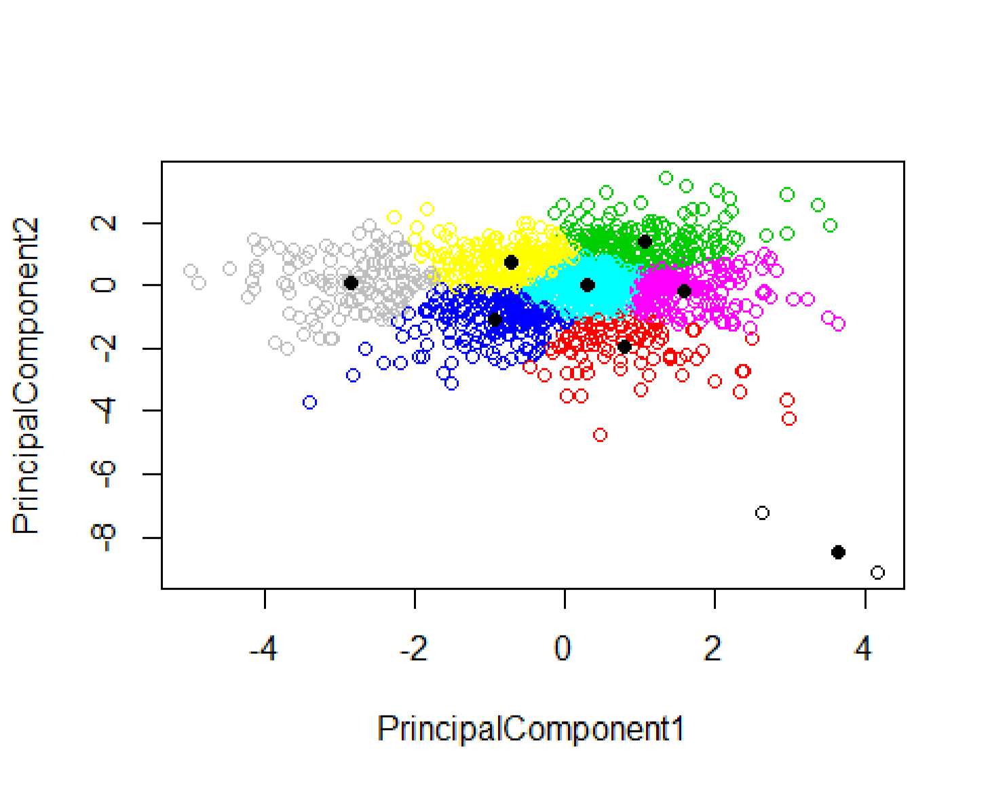

|  |  |
| --- | --- |
| **names**(yeast)<- **c**("SequenceName", "mcg", "gvh", "alm", "mit", "erl", "pox", " v |  |
| ac", "nuc", "LocalizationSite") **aggregate**(yeast[, 2**:**9],by=**list**(km**$**cluster),mean)  ## Group.1 mcg gvh alm mit erl pox  ## 1 1 0.3766667 0.2133333 0.9300000 0.7966667 0.5000000 0.000000000  ## 2 2 0.4693636 0.4452727 0.5797273 0.3632727 0.5000000 0.004545455  ## 3 3 0.3833333 0.4115104 0.4686458 0.1800000 0.5052083 0.000000000 |

## 4 4 0.5817277 0.5768063 0.5130366 0.4321466 0.5026178 0.004345550

|  |
| --- |
| ## 5 5 0.4792231 0.4787719 0.5196992 0.2337343 0.5000000 0.012080201  ## 6 6 0.3757286 0.3686935 0.5618593 0.2151759 0.5000000 0.004170854  ## 7 7 0.5357692 0.5591154 0.4424231 0.2018462 0.5096154 0.012769231 ## 8 8 0.7648462 0.7179231 0.4101538 0.3045385 0.5230769 0.006384615 ## vac nuc  ## 1 0.1600000 0.006666667  ## 2 0.4034545 0.215727273  ## 3 0.5272396 0.408750000  ## 4 0.4853927 0.240471204  ## 5 0.5055138 0.259548872  ## 6 0.4818090 0.276532663  ## 7 0.5303462 0.273076923 ## 8 0.5196923 0.247153846 **table**(km**$**cluster, yeast**$**LocalizationSite)  ##  ## CYT ERL EXC ME1 ME2 ME3 MIT NUC POX VAC  ## 1 3 0 0 0 0 0 0 0 0 0  ## 2 48 0 2 0 0 0 32 26 1 1  ## 3 45 0 0 0 4 49 3 88 0 3  ## 4 36 0 12 1 3 2 113 21 1 2  ## 5 179 0 1 0 0 25 48 130 10 6  ## 6 76 0 0 0 0 3 11 105 1 3  ## 7 73 0 0 0 14 78 23 57 5 10  ## 8 3 5 20 43 30 6 14 2 2 5  *#Spectral Clustering* **library**(kknn)  ## Warning: package 'kknn' was built under R version 3.5.1  cl <- **specClust**(clustering.data, centers=8, nn=50, iter.max=100)  cl  ## K-means clustering with 8 clusters of sizes 186, 219, 195, 156, 172, 161, 235, 160  ##  ## Cluster means:  ## [,1] [,2] [,3] [,4] [,5] [,6]  ## 1 -0.3808008 -0.010307326 -0.335345170 -0.34971429 -0.12569821 0.12122808  ## 2 -0.3859207 -0.356402209 0.001120503 -0.18897403 0.15872031 0.42663259  ## 3 -0.3490415 0.263465580 -0.365421550 0.18599020 -0.39027381 -0.23528531  ## 4 -0.3706620 0.009057016 0.499097988 -0.08118804 0.25164079 -0.49508121  ## 5 -0.3261405 0.473393062 0.201756081 0.43978983 0.28173634 0.29245070  ## 6 -0.3113686 -0.308406853 -0.445304695 0.27223211 0.38520253 -0.27321926  ## 7 -0.3971609 0.303283449 0.099096132 -0.38195357 -0.03938998 -0.02858538 ## 8 -0.3253228 -0.481735595 0.380420920 0.30376846 -0.43922822 0.00971019 ## [,7] [,8]  ## 1 0.2889526 0.51087588 |

## 2 0.1959341 -0.34792688

## 3 0.1942592 -0.29581023

## 4 0.2549182 -0.02314869

|  |
| --- |
| ## 5 0.1178271 0.14336792  ## 6 -0.3357884 -0.03074654  ## 7 -0.5215953 -0.04244720  ## 8 -0.1457893 0.17068547  ##  ## Clustering vector:  ## [1] 2 2 4 7 6 1 2 7 6 5 7 3 1 2 2 7 5 7 3 2 7 7 8 7 4 2 4 1 2 8 4 6 5 1  ## [35] 8 8 8 7 2 2 8 8 8 4 3 3 6 1 8 5 7 5 1 1 2 2 2 2 1 6 1 3 7 7 4 4 5 7  ## [69] 7 8 7 4 6 6 6 6 2 2 6 6 1 2 2 6 8 5 5 8 1 1 3 7 3 5 2 1 8 8 8 6 2 7  ## [103] 6 3 1 4 7 1 4 7 1 7 5 1 5 6 6 6 6 3 8 2 2 2 4 2 3 2 1 3 2 1 6 2 7 7  ## [137] 5 7 3 3 3 2 2 1 7 5 1 7 5 1 7 5 7 7 4 3 3 8 1 8 3 3 7 5 4 5 7 7 7 5  ## [171] 3 2 2 3 2 1 3 1 3 6 3 1 1 2 2 7 7 5 2 5 8 8 7 2 2 6 6 8 8 7 2 3 2 6  ## [205] 4 8 6 6 6 6 6 2 8 2 4 7 8 1 8 8 4 4 2 6 6 4 6 3 8 6 7 1 5 8 8 1 3 3  ## [239] 1 1 7 1 1 3 5 1 2 3 4 5 1 4 3 1 4 6 3 3 3 7 3 3 2 4 3 2 3 7 4 4 3 1  ## [273] 5 2 3 1 8 7 2 3 5 8 5 2 2 5 8 8 4 2 4 4 8 4 8 4 7 3 7 4 4 2 5 5 8 8  ## [307] 5 7 2 4 3 2 2 2 5 2 5 5 8 2 4 3 8 5 4 8 8 7 1 6 5 8 4 8 2 3 2 5 4 6  ## [341] 4 7 1 2 4 1 8 3 1 5 7 3 2 5 5 7 7 3 1 1 5 1 1 8 3 7 4 5 5 7 7 7 3 7  ## [375] 7 7 5 4 4 3 2 3 1 5 5 1 1 7 7 1 2 3 4 6 3 4 5 7 5 2 3 3 6 4 7 5 3 3  ## [409] 6 6 4 5 4 7 4 8 3 1 3 1 7 7 5 5 8 6 4 3 2 2 7 4 2 6 4 1 1 3 3 2 3 1  ## [443] 7 7 5 4 7 4 4 5 1 2 6 1 2 2 7 2 6 6 1 2 7 6 7 1 3 1 4 5 8 2 4 4 4 6  ## [477] 5 4 1 1 5 7 8 8 8 4 3 3 8 3 4 8 8 6 2 8 8 7 3 7 2 6 3 6 3 8 8 4 6 7  ## [511] 1 8 8 8 8 3 7 6 5 3 6 2 3 7 4 5 2 7 6 7 2 5 7 5 7 6 2 5 4 1 3 5 3 3  ## [545] 5 3 1 6 2 8 7 8 7 6 3 7 2 4 2 6 2 8 7 3 2 2 2 4 8 4 2 1 4 1 7 2 2 3  ## [579] 6 8 8 6 2 1 7 5 3 7 4 2 4 1 1 8 8 8 2 7 6 2 5 2 6 6 1 6 1 6 6 2 3 6  ## [613] 1 6 1 6 6 2 2 2 6 1 6 6 6 6 2 6 1 2 2 2 2 2 8 2 3 2 5 2 2 6 2 3 7 7  ## [647] 2 1 6 2 1 2 6 1 7 7 3 3 7 4 7 6 4 2 8 4 1 6 3 1 2 7 1 3 7 2 8 4 2 2  ## [681] 2 5 5 3 3 5 4 7 5 7 3 5 5 3 3 8 5 3 8 5 7 8 7 2 6 2 3 8 8 5 8 4 6 1  ## [715] 6 7 5 5 5 8 3 3 1 2 2 1 1 6 1 7 4 2 6 7 1 7 1 4 7 8 5 2 5 3 2 8 7 7  ## [749] 8 7 3 2 1 2 8 6 1 3 1 2 6 1 7 2 5 6 3 1 4 7 5 6 8 8 7 8 3 8 4 4 5 3  ## [783] 5 6 2 5 6 6 6 6 2 8 4 5 5 7 8 8 5 5 7 4 7 7 3 7 7 3 4 1 4 6 1 8 2 7  ## [817] 3 2 8 8 2 2 2 2 1 1 6 3 6 7 8 7 3 1 3 3 7 1 7 3 3 5 1 5 1 7 7 1 2 2  ## [851] 2 1 8 1 3 5 6 3 7 2 2 7 4 1 7 2 2 1 2 2 3 2 5 1 3 3 7 5 1 1 1 5 5 1  ## [885] 2 3 1 2 1 1 5 5 5 2 7 7 1 2 1 1 3 2 3 3 7 4 5 3 3 1 7 1 1 4 3 2 2 5  ## [919] 6 1 2 1 5 2 1 1 6 3 3 3 1 6 6 6 6 6 6 1 4 3 7 7 1 7 7 2 3 3 3 1 1 6  ## [953] 6 7 3 5 3 3 7 5 5 3 6 6 6 6 4 4 1 7 7 1 1 6 6 6 6 6 2 2 3 3 2 1 6 6  ## [987] 6 6 6 6 6 1 1 6 3 1 4 4 4 8 8 7 2 4 2 3 6 6 3 3 1 3 3 3 1 1 1 1 1 1  ## [1021] 1 2 6 5 2 2 3 3 7 6 3 3 6 4 1 3 8 2 5 8 7 5 2 7 6 6 8 2 7 4 8 4 3 5  ## [1055] 7 7 7 4 4 4 4 7 1 7 4 7 8 4 8 7 4 5 2 4 3 7 8 8 3 5 1 5 7 2 8 8 4 2  ## [1089] 7 8 6 1 1 2 6 1 5 5 5 7 7 7 4 6 5 5 7 8 4 3 7 7 5 4 3 4 5 2 2 5 5 7  ## [1123] 5 7 1 6 6 3 4 2 4 4 6 3 1 3 6 6 7 4 1 7 2 6 7 7 5 7 3 5 1 4 2 2 7 5  ## [1157] 7 7 7 4 2 6 7 3 7 3 1 5 1 7 5 4 7 7 1 7 7 7 3 2 7 5 6 7 5 8 7 7 8 1  ## [1191] 5 4 6 4 5 8 3 4 2 6 3 4 7 7 3 4 8 8 8 8 1 3 2 5 7 7 3 3 3 2 3 7 5 5  ## [1225] 7 8 7 2 5 7 1 7 7 7 2 7 1 2 1 2 7 3 7 7 7 7 8 1 4 4 1 5 5 1 2 3 3 3  ## [1259] 3 7 3 3 5 4 4 8 1 8 8 2 2 7 3 1 5 5 1 2 1 3 6 3 3 3 2 1 5 5 2 7 7 2  ## [1293] 3 7 4 1 2 2 2 8 1 1 1 7 8 6 3 2 4 2 4 4 4 7 6 4 3 5 5 5 4 3 7 1 7 7  ## [1327] 7 6 6 5 1 4 4 7 7 8 3 8 7 2 1 2 6 4 5 7 8 7 3 2 8 7 1 7 8 4 8 3 8 5  ## [1361] 4 2 4 8 8 7 7 2 7 8 5 7 1 6 3 5 5 4 3 2 4 5 5 5 5 4 8 3 7 4 4 8 8 8 |

## [1395] 4 6 6 6 4 8 7 5 8 4 1 4 7 7 8 1 8 5 7 2 7 5 2 5 7 4 8 4 3 8 8 5 4 7

|  |
| --- |
| ## [1429] 2 1 5 2 8 4 8 5 8 8 4 8 8 5 8 8 2 4 6 5 5 2 8 3 5 3 6 5 8 7 2 5 2 8  ## [1463] 6 5 5 4 5 6 7 1 2 7 4 2 1 2 2 6 6 8 3 8 5 2 ##  ## Within cluster sum of squares by cluster:  ## [1] 45.59679 70.44780 60.00491 36.33080 40.60411 32.00669 74.81030 29.0714  8  ## (between_SS / total_SS = 69.9 %) ##  ## Available components:  ##  ## [1] "cluster" "centers" "totss" "withinss"  ## [5] "tot.withinss" "betweenss" "size" "iter"  ## [9] "ifault" "eigenvalue" "eigenvector" "data" ## [13] "indAll" "indUnique" "L" "archetype"  ## [17] "call" **plot**(PrincipalComponent1, PrincipalComponent2, col=cl**$**cluster) |

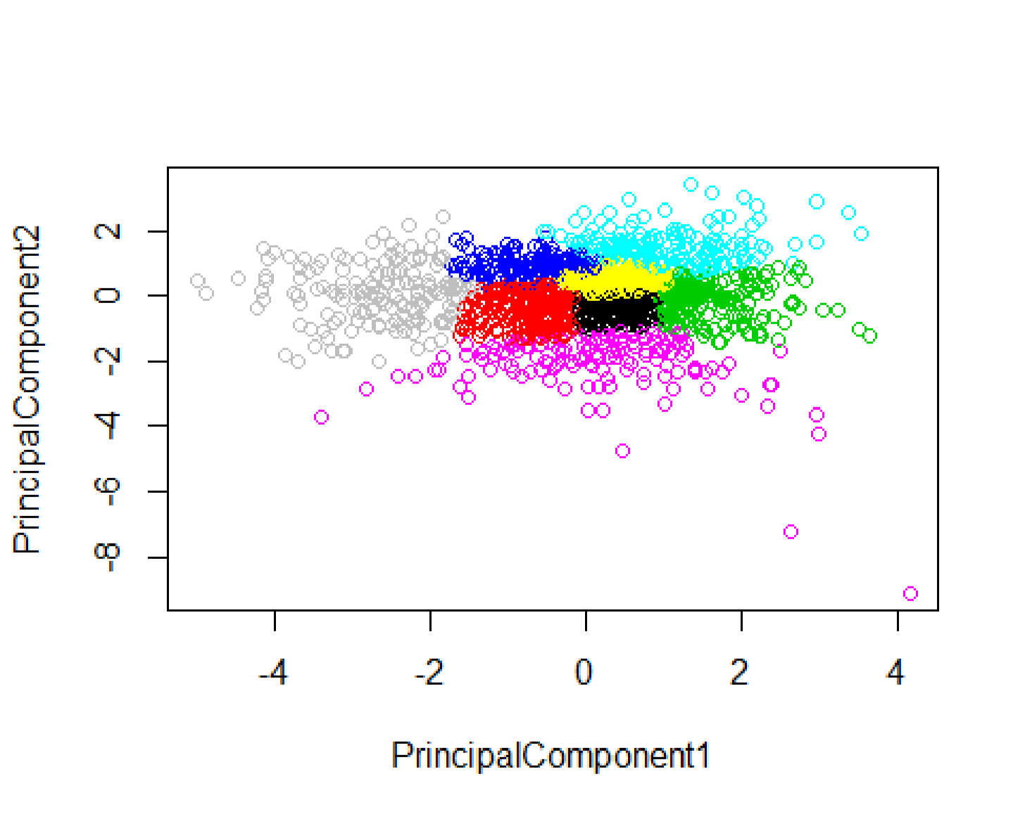

|  |  |
| --- | --- |
| **table**(cl**$**cluster, yeast**$**LocalizationSite) | 4 |
| ##  ## CYT ERL EXC ME1 ME2 ME3 MIT NUC POX VAC  ## 1 71 0 1 0 0 3 31 70 9 1  ## 2 72 0 2 0 2 11 93 33 2  ## 3 74 0 0 0 1 3 11 102 1 3  ## 4 42 0 0 0 10 55 8 34 2 5 |

## 5 35 0 0 0 2 50 2 80 0 3

## 6 52 0 7 1 2 0 67 29 2 1

## 7 110 0 0 0 1 29 12 75 2 6

|  |
| --- |
| ## 8 7 5 25 43 33 12 20 6 2 7 **aggregate**(yeast[, 2**:**9],by=**list**(cl**$**cluster),mean)  ## Group.1 mcg gvh alm mit erl pox  ## 1 1 0.4755914 0.4774731 0.5415054 0.2611290 0.5000000 0.018763441  ## 2 2 0.5599087 0.5620548 0.5038813 0.3309132 0.5022831 0.013652968  ## 3 3 0.3738462 0.3676923 0.5625641 0.2140000 0.5000000 0.004256410  ## 4 4 0.5244231 0.5530769 0.4301282 0.1937821 0.5096154 0.005320513  ## 5 5 0.3816860 0.4130233 0.4589535 0.1778488 0.5087209 0.000000000  ## 6 6 0.5042236 0.4885714 0.5668323 0.4272671 0.5000000 0.003105590  ## 7 7 0.4680426 0.4667660 0.4985957 0.2000000 0.5000000 0.007063830 ## 8 8 0.7473125 0.7039375 0.4175625 0.3013750 0.5218750 0.005187500 ## vac nuc  ## 1 0.4927957 0.2497312  ## 2 0.5059817 0.2422831  ## 3 0.4819487 0.2754359  ## 4 0.5362179 0.2767949  ## 5 0.5279651 0.4241860  ## 6 0.4114907 0.2188199  ## 7 0.5174043 0.2804681  ## 8 0.5192500 0.2461250  *#Hierarchical Clustering* d_yeast<- **dist**(clustering.data)  hclusters <- **hclust**(d_yeast, method = "average") clusterCut <- **cutree**(hclusters, 8) clusterCut  ## [1] 1 1 2 1 1 1 1 1 1 1 1 1 1 1 1 1 1 1 1 1 1 1 2 1 1 1 1 1 2 2 3 2 1 1  ## [35] 2 2 2 1 1 1 2 2 2 1 1 1 4 1 2 1 1 3 1 1 1 1 1 1 1 1 1 1 1 1 1 1 1 1  ## [69] 1 2 1 1 2 1 1 1 1 1 1 1 1 1 1 1 2 3 1 2 1 1 1 1 1 3 1 1 2 2 2 1 1 1  ## [103] 1 1 1 1 1 1 2 1 1 1 1 1 3 1 2 1 5 1 2 1 2 1 2 1 1 2 1 1 1 1 1 1 1 1  ## [137] 1 1 1 1 1 1 1 1 1 3 1 1 3 1 1 3 1 1 1 1 1 2 1 2 1 1 1 1 1 1 1 1 1 3  ## [171] 1 1 1 1 1 1 1 1 1 1 1 1 1 1 1 1 1 1 1 1 2 2 1 1 2 1 1 2 2 1 1 1 1 1  ## [205] 2 2 1 1 1 1 1 1 2 1 1 1 2 1 2 2 2 1 1 1 1 1 1 1 2 1 1 1 3 2 2 1 1 1  ## [239] 1 1 1 1 1 1 3 1 1 1 1 1 1 1 1 1 1 1 1 1 1 1 1 1 1 1 1 1 1 1 1 1 1 1  ## [273] 3 1 1 1 2 1 1 1 1 2 1 1 1 1 2 2 1 1 1 1 2 1 2 1 1 1 1 1 2 1 1 1 2 2  ## [307] 3 1 1 2 1 1 1 1 1 1 1 3 2 1 1 1 2 3 1 2 2 1 1 1 1 2 1 2 1 1 1 1 1 1  ## [341] 1 1 1 1 1 1 2 1 1 1 1 1 1 1 3 1 1 1 1 1 3 1 1 2 1 1 1 1 1 1 1 1 1 1  ## [375] 1 1 3 1 1 1 1 1 1 3 1 1 1 1 1 1 2 1 1 5 1 2 3 1 1 2 1 1 1 1 1 1 1 1  ## [409] 5 5 1 1 1 1 2 2 1 1 1 1 1 1 1 1 2 1 1 1 1 1 1 1 1 1 1 1 1 1 1 2 1 1  ## [443] 1 1 1 1 1 1 1 1 1 1 1 1 1 1 1 1 1 1 1 1 1 1 1 1 1 1 1 1 2 1 1 1 1 5  ## [477] 1 2 1 1 1 1 2 2 2 1 1 1 2 1 1 2 2 1 1 2 2 1 1 1 1 1 1 4 1 2 2 1 4 1  ## [511] 1 2 2 2 2 1 1 1 1 1 1 2 1 1 1 1 1 1 1 1 1 3 1 3 1 1 1 1 1 1 1 1 1 1  ## [545] 1 1 1 1 1 2 1 2 1 5 1 1 1 2 1 1 1 2 1 1 1 1 1 2 2 1 1 1 1 1 1 1 1 1  ## [579] 1 4 2 1 1 1 1 3 1 1 2 2 1 1 1 2 2 2 1 1 1 1 3 2 1 1 1 1 1 1 1 1 1 1  ## [613] 1 1 1 1 1 1 1 1 1 1 1 1 2 1 1 1 1 1 1 2 1 1 2 1 1 1 1 1 1 1 1 1 1 1 |

## [647] 1 1 2 2 1 1 1 1 1 1 1 1 1 1 1 1 1 1 2 1 1 1 1 1 1 1 1 1 1 2 2 1 1 1

|  |
| --- |
| ## [681] 1 3 1 1 1 1 1 1 3 1 1 3 3 1 1 2 1 1 2 1 1 2 1 2 4 1 1 2 2 1 2 2 2 1  ## [715] 1 1 3 3 3 2 1 1 1 1 1 1 1 2 1 1 1 1 1 1 1 1 1 1 1 2 3 1 1 1 1 2 1 1  ## [749] 2 1 1 1 1 1 2 1 1 1 1 1 2 1 1 1 3 1 1 1 1 1 3 1 2 2 1 2 1 2 2 1 1 1  ## [783] 3 1 2 1 1 4 4 4 1 2 1 3 1 1 2 2 3 1 1 1 1 1 1 1 1 1 1 1 1 5 1 2 1 1  ## [817] 1 1 2 2 2 1 1 1 1 1 1 1 1 1 2 1 1 1 1 1 1 1 1 1 1 3 1 3 1 1 1 1 1 1  ## [851] 1 1 2 1 1 3 1 1 1 2 1 1 2 1 1 1 1 1 1 1 1 1 3 1 1 1 1 1 1 1 1 3 3 1  ## [885] 1 1 1 1 1 1 1 1 1 1 1 1 1 1 1 1 1 1 1 1 1 1 1 1 1 1 1 1 1 1 1 1 1 3  ## [919] 1 1 1 1 1 2 1 1 5 1 1 1 1 1 1 1 1 5 5 1 1 1 1 1 1 1 1 1 1 1 1 1 1 1  ## [953] 1 1 1 1 1 1 1 3 3 1 5 5 1 1 1 1 1 1 1 1 1 5 1 1 1 1 2 2 1 1 1 1 1 1  ## [987] 5 5 6 6 6 1 1 1 1 1 1 2 2 2 2 1 1 1 1 1 1 1 1 1 1 1 1 1 1 1 1 1 1 1  ## [1021] 1 1 5 3 1 1 1 1 1 1 1 1 1 1 1 1 2 1 1 2 1 1 1 1 2 1 2 1 1 1 2 1 1 1  ## [1055] 1 1 1 1 1 1 1 1 1 1 1 1 2 1 2 1 1 1 1 1 1 1 2 2 1 3 1 3 1 1 2 2 1 1  ## [1089] 1 2 5 1 1 1 1 1 3 1 3 1 1 1 1 1 1 3 1 2 2 7 1 1 1 1 1 1 3 1 1 1 1 1  ## [1123] 3 1 1 8 1 1 1 1 1 1 1 1 1 1 5 5 1 1 1 1 2 4 1 1 3 1 1 3 1 1 1 1 1 3  ## [1157] 1 1 1 1 1 1 1 1 1 1 1 1 1 1 3 1 1 1 1 1 1 1 1 1 1 3 5 1 1 2 1 1 2 1  ## [1191] 1 1 5 1 3 2 1 1 1 1 7 1 1 1 1 1 2 2 2 2 1 1 1 3 1 1 1 1 1 1 1 1 3 3  ## [1225] 1 2 1 1 1 1 1 1 1 1 1 1 1 1 1 1 1 1 1 1 1 1 2 1 1 1 1 1 3 1 1 1 1 1  ## [1259] 1 1 1 1 1 1 1 2 1 2 2 1 1 1 1 1 3 3 1 1 1 1 1 1 1 1 1 1 1 1 1 1 1 1  ## [1293] 1 1 2 1 1 1 1 2 1 1 1 1 2 1 1 1 1 1 1 1 1 1 5 1 1 3 1 1 1 1 1 1 1 1  ## [1327] 1 5 5 1 1 1 1 1 1 2 1 2 1 1 1 1 1 1 1 1 2 1 1 1 2 1 1 1 2 1 2 1 2 1  ## [1361] 1 1 1 2 2 1 1 1 1 2 1 1 1 1 1 3 3 1 1 1 1 1 3 1 1 1 2 1 1 1 1 2 2 2  ## [1395] 1 1 1 1 1 2 1 1 2 2 1 1 1 1 2 1 2 1 1 1 1 3 1 1 1 1 2 2 1 2 2 3 1 1 ## [1429] 1 1 3 1 2 1 2 3 2 2 1 2 2 1 2 2 1 1 1 3 3 1 2 1 3 1 4 3 2 1 1 3 1 2  ## [1463] 1 1 3 1 3 1 1 1 2 1 1 1 1 1 1 5 5 2 1 2 1 1 **table**(clusterCut, yeast**$**LocalizationSite)  ##  ## clusterCut CYT ERL EXC ME1 ME2 ME3 MIT NUC POX VAC  ## 1 411 0 4 0 14 130 194 358 17 21  ## 2 16 5 25 43 36 19 46 10 3 9  ## 3 16 0 0 0 0 14 2 49 0 0  ## 4 0 0 6 1 1 0 0 2 0 0  ## 5 17 0 0 0 0 0 1 8 0 0  ## 6 3 0 0 0 0 0 0 0 0 0  ## 7 0 0 0 0 0 0 1 1 0 0 ## 8 0 0 0 0 0 0 0 1 0 0 **aggregate**(yeast[, 2**:**9],by=**list**(clusterCut),mean)  ## Group.1 mcg gvh alm mit erl pox  ## 1 1 0.4715405 0.4762228 0.5104178 0.2522715 0.5013055 0.008964317  ## 2 2 0.7120283 0.6790566 0.4296698 0.3211792 0.5188679 0.003915094  ## 3 3 0.3545679 0.3871605 0.4807407 0.1697531 0.5185185 0.000000000  ## 4 4 0.7750000 0.7390000 0.5210000 0.4280000 0.5000000 0.000000000  ## 5 5 0.4115385 0.4076923 0.5992308 0.3080769 0.5000000 0.000000000  ## 6 6 0.3766667 0.2133333 0.9300000 0.7966667 0.5000000 0.000000000  ## 7 7 0.2350000 0.1700000 0.7000000 0.3100000 0.5000000 0.000000000 ## 8 8 0.6600000 0.4300000 0.5700000 0.6000000 0.5000000 0.000000000 ## vac nuc |

## 1 0.5007659 0.268398607

## 2 0.5205189 0.248867925

## 3 0.5237037 0.497530864

|  |
| --- |
| ## 4 0.3660000 0.241000000  ## 5 0.3219231 0.200384615  ## 6 0.1600000 0.006666667  ## 7 0.4900000 0.230000000 ## 8 0.1900000 0.330000000 **plot**(PrincipalComponent1, PrincipalComponent2, col=clusterCut) |

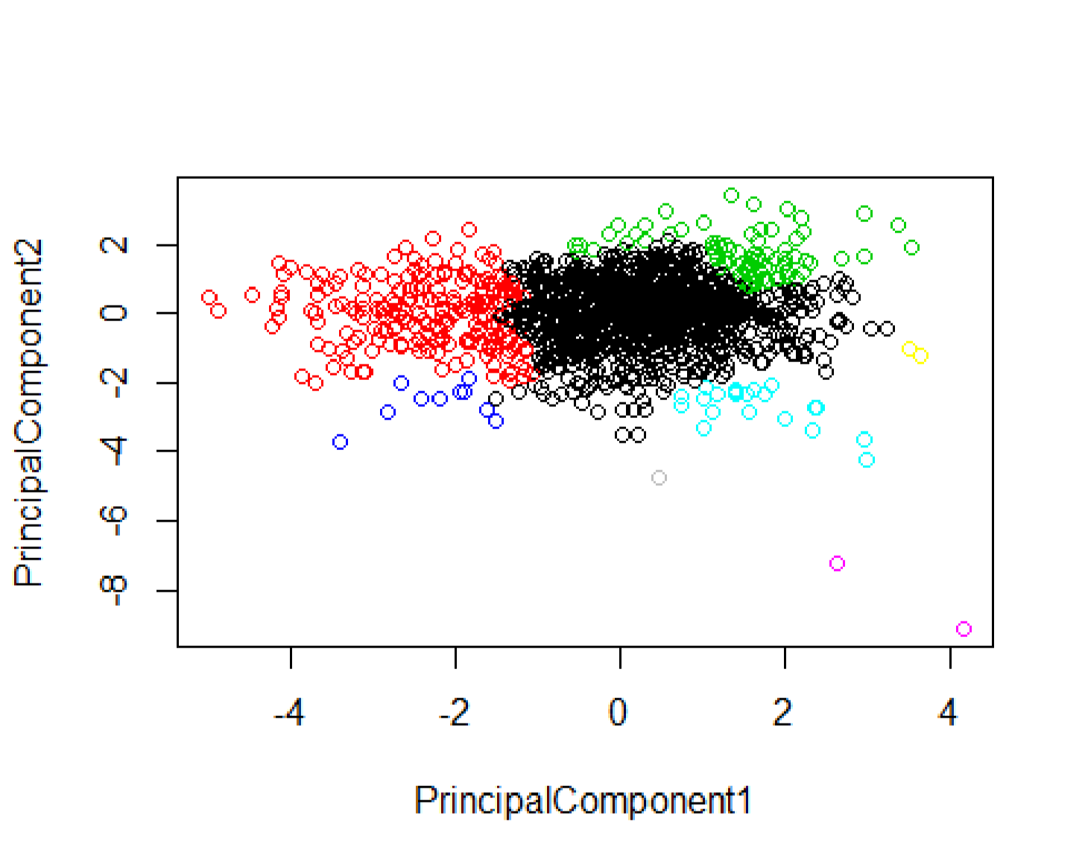

|  |  |
| --- | --- |
| *# Show a random sample* | 10)  ## SequenceName mcg gvh alm mit erl pox vac nuc LocalizationSite  ## 169 CHS2_YEAST 0.39 0.42 0.38 0.40 0.5 0 0.49 0.47 ME3  0.5 0 0.60 0.22 CYT  ## 903 R104_YEAST 0.44 0.33 0.55 0.16 0.5 0 0.49 0.22 NUC  ## 924 RN12_YEAST 0.56 0.51 0.32 0.49 0.5 0 0.48 0.22 NUC  ## 1275 TOP1_YEAST 0.41 0.42 0.53 0.17 0.5 0 0.48 0.58 NUC  ## 948 RPB5_YEAST 0.40 0.30 0.57 0.13 0.5 0 0.46 0.22 NUC  ## 15 ACR1_YEAST 0.66 0.55 0.45 0.19 0.5 0 0.46 0.22 MIT  ## 344 GAL8_YEAST 0.60 0.60 0.49 0.30 0.5 0 0.53 0.22 NUC  0.38 0.43 0.53 0.22 0.5 0 0.48 0.11 CYT  ## 759 PT91_YEAST 0.59 0.45 0.58 0.21 0.5 0 0.49 0.22 MIT |
| **set.seed**(1234) dplyr**::sample_n**( yeast,  ## 923 RNA1_YEAST 0.45 0.52 0.50 0.12  ## 984 RL34_YEAST |

|  |  |
| --- | --- |
| *# Show the levels* | yeast, SequenceName) **%>%**  nuc, na.rm = TRUE),  na.rm = TRUE)    ## SequenceName count mean sd  ## <chr> <int> <dbl> <dbl>  ## 1 6P2K_YEAST 1 0.3 NaN  ## 2 6PGD_YEAST 1 0.31 NaN  AAR2_YEAST 1 0.22 NaN  ## 4 AATC_YEAST 1 0.22 NaN  ## 5 AATM_YEAST 1 0.22 NaN  ## 6 ABC1_YEAST 1 0.22 NaN  ## 7 ABF2_YEAST 1 0.22 NaN  ## 8 ABP1_YEAST 1 0.3 NaN  ## 9 ACE1_YEAST 1 0.27 NaN  ACE2_YEAST 1 0.290 NaN |
| **levels**(yeast**$** group)  ## NULL  **library**(dplyr) **group_by**( **summarise**( count = **n**(), mean = **mean**( sd = **sd**(nuc, )  ## # A tibble: 1,462 x 4  ## 3  ## 10  ## # ... with 1,452 more rows |

1. Perform ANOVA test on the discriminant analysis scores of nuclear localization signals of both nuclear and non-nuclear proteins by class variables (Target).
2. Which class is significantly different from others?

|  |
| --- |
| *# Compute the analysis of variance*  res.aov<-**aov**(nuc**~** LocalizationSite,data=yeast) **summary**(res.aov)  ## Df Sum Sq Mean Sq F value Pr(>F)  ## LocalizationSite 9 1.993 0.22141 22.01 <2e-16 *** ## Residuals 1474 14.825 0.01006 ## ---  ## Signif. codes: 0 '***' 0.001 '**' 0.01 '*' 0.05 '.' 0.1 ' ' 1  res.aov <- **aov**(nuc **~** vac, data = yeast)  *# Summary of the analysis* **summary**(res.aov) |
| ## Df Sum Sq Mean Sq F value Pr(>F)  ## vac 1 0.135 0.13529 12.02 0.000542 *** ## Residuals 1482 16.682 0.01126 ## ---  ## Signif. codes: 0 '***' 0.001 '**' 0.01 '*' 0.05 '.' 0.1 ' ' 1  res.aov <- **aov**(nuc **~** pox, data = yeast) **summary**(res.aov)  ## Df Sum Sq Mean Sq F value Pr(>F)  ## pox 1 0.021 0.02138 1.887 0.17  ## Residuals 1482 16.796 0.01133  res.aov <- **aov**(nuc **~** erl, data = yeast) **summary**(res.aov)  ## Df Sum Sq Mean Sq F value Pr(>F) ## erl 1 0.00 0.000135 0.012 0.913  ## Residuals 1482 16.82 0.011348  res.aov <- **aov**(nuc **~**mit , data = yeast) **summary**(res.aov)  ## Df Sum Sq Mean Sq F value Pr(>F)  ## mit 1 0.05 0.05050 4.463 0.0348 * ## Residuals 1482 16.77 0.01131 ## ---  ## Signif. codes: 0 '***' 0.001 '**' 0.01 '*' 0.05 '.' 0.1 ' ' 1  res.aov <- **aov**(nuc **~**alm , data = yeast) **summary**(res.aov)  ## Df Sum Sq Mean Sq F value Pr(>F) ## alm 1 0.008 0.008171 0.72 0.396  ## Residuals 1482 16.809 0.011342  res.aov <- **aov**(nuc **~**gvh , data = yeast) **summary**(res.aov)  ## Df Sum Sq Mean Sq F value Pr(>F)  ## gvh 1 0.178 0.17836 15.89 7.05e-05 *** ## Residuals 1482 16.639 0.01123 ## ---  ## Signif. codes: 0 '***' 0.001 '**' 0.01 '*' 0.05 '.' 0.1 ' ' 1  res.aov <- **aov**(nuc **~** mcg, data = yeast) **summary**(res.aov)  ## Df Sum Sq Mean Sq F value Pr(>F)  ## mcg 1 0.261 0.26085 23.35 1.49e-06 ***  ## Residuals 1482 16.557 0.01117 |
| ## ---  ## Signif. codes: 0 '***' 0.001 '**' 0.01 '*' 0.05 '.' 0.1 ' ' 1 |